Gilgit:

Hunza Valley

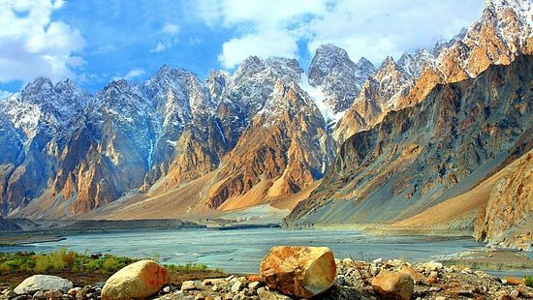

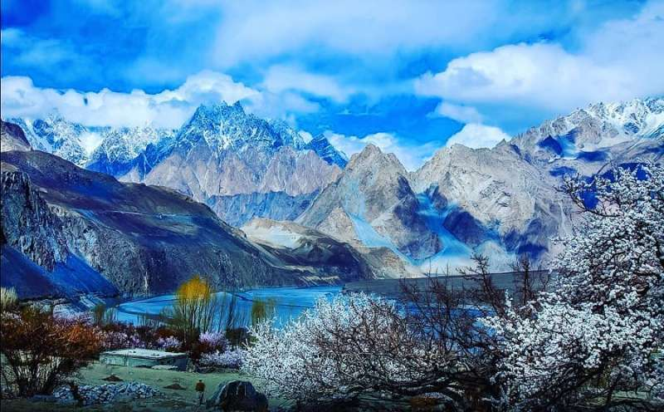

**Hunza** is a mountainous valley in the Gilgit-Baltistan region of Pakistan. Hunza is situated in the extreme northern part of Pakistan, bordering with the Wakhan Corridor of Afghanistan and the Xinjiang region of China. Hunza was formerly a princely state bordering Xinjiang (autonomous region of China) to the northeast and Pamir to the northwest, which survived until 1974, when it was finally dissolved by Zulfikar Ali Bhutto. The state bordered the Gilgit Agency to the south and the former princely state of Nagar to the east. The state capital was the town of Baltit (also known as Karimabad); another old settlement is Ganish Village which means "ancient gold" village.